*ViT Transformer Model X EfficientNetB4 Hybrid Model Observation and Analysis*

* *First Training Test*

| **Parameter** | **Value** |
| --- | --- |
| Learning Rate | 0.0001 |
| Epochs | 30 |
| Rotation Range | 20 |
| Width Shift Range | 0.2 |
| Height Shift Range | 0.2 |
| Shear Range | 0.2 |
| Zoom Range | 0.2 |
| Horizontal Flip | True |

* *Result and Observation*

| **Epoch** | **Training Loss** | **Training Accuracy** | **Validation Loss** | **Validation Accuracy** | **Learning Rate** |
| --- | --- | --- | --- | --- | --- |
| 1 | 1.4789 | 0.8206 | 1.1876 | 0.9222 | 1.0000e-04 |
| 2 | 1.1955 | 0.9154 | 1.1417 | 0.9348 | 1.0000e-04 |
| 3 | 1.1354 | 0.9266 | 1.0073 | 0.9662 | 1.0000e-04 |
| 4 | 1.0466 | 0.9450 | 0.9411 | 0.9772 | 1.0000e-04 |
| 5 | 0.9790 | 0.9509 | 0.9963 | 0.9466 | 1.0000e-04 |
| 6 | 0.9296 | 0.9553 | 0.8812 | 0.9678 | 1.0000e-04 |
| 7 | 0.8675 | 0.9592 | 0.7912 | 0.9764 | 1.0000e-04 |
| 8 | 0.8216 | 0.9622 | 0.8174 | 0.9599 | 1.0000e-04 |
| 9 | 0.7544 | 0.9692 | 0.7574 | 0.9615 | 1.0000e-04 |
| 10 | 0.7205 | 0.9688 | 0.7142 | 0.9623 | 1.0000e-04 |
| 11 | 0.6716 | 0.9702 | 0.6740 | 0.9662 | 1.0000e-04 |
| 12 | 0.6095 | 0.9785 | 0.6073 | 0.9764 | 1.0000e-04 |
| 13 | 0.5971 | 0.9681 | 0.5843 | 0.9709 | 1.0000e-04 |
| 14 | 0.5335 | 0.9785 | 0.5255 | 0.9788 | 1.0000e-04 |
| 15 | 0.4971 | 0.9769 | 0.4726 | 0.9843 | 1.0000e-04 |
| 16 | 0.4631 | 0.9797 | 0.4347 | 0.9859 | 1.0000e-04 |
| 17 | 0.4087 | 0.9883 | 0.3976 | 0.9890 | 1.0000e-04 |
| 18 | 0.3958 | 0.9809 | 0.3794 | 0.9843 | 1.0000e-04 |
| 19 | 0.3732 | 0.9778 | 0.3964 | 0.9741 | 1.0000e-04 |
| 20 | 0.3281 | 0.9821 | 0.3344 | 0.9827 | 1.0000e-04 |
| 21 | 0.3179 | 0.9770 | 0.3472 | 0.9764 | 1.0000e-04 |
| 22 | 0.2922 | 0.9770 | 0.3061 | 0.9749 | 1.0000e-04 |
| 23 | 0.2603 | 0.9837 | 0.2454 | 0.9866 | 1.0000e-04 |
| 24 | 0.2333 | 0.9869 | 0.2945 | 0.9615 | 1.0000e-04 |
| ***25*** | ***0.2183*** | ***0.9846*** | ***0.2108*** | ***0.9898*** | ***1.0000e-04*** |
| 26 | 0.2328 | 0.9767 | 0.2556 | 0.9670 | 1.0000e-04 |
| 27 | 0.1810 | 0.9870 | 0.1922 | 0.9851 | 1.0000e-04 |
| 28 | 0.1701 | 0.9860 | 0.1634 | 0.9851 | 1.0000e-04 |
| 29 | 0.1763 | 0.9809 | 0.1704 | 0.9804 | 1.0000e-04 |
| 30 | 0.1634 | 0.9807 | 0.1660 | 0.9804 | 1.0000e-04 |

**Test-Accuracy Obtained: 98.97878766059875%**

**Test-Loss: 0.21083767712116241**

* *Plotting Graph:*

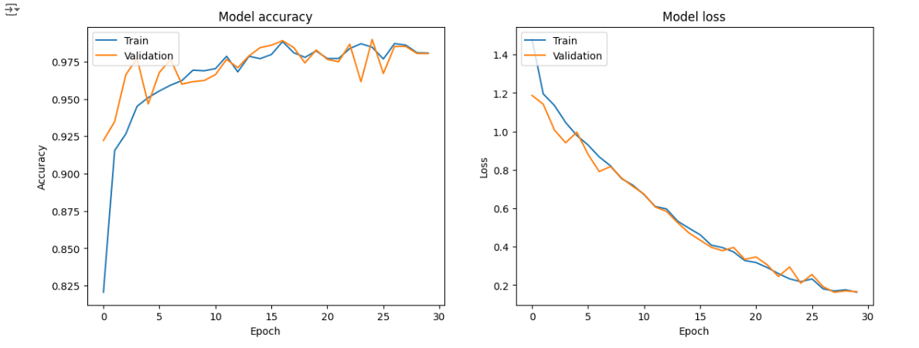

* *Screenshot:*

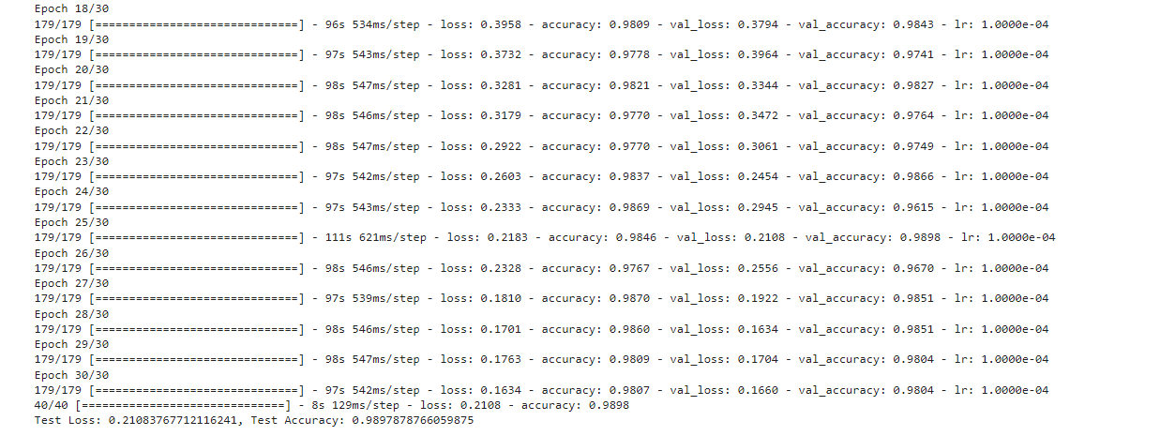

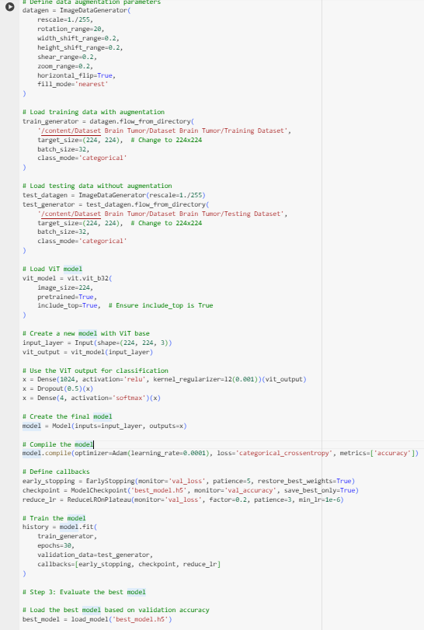

* *Second Training Test*

| **Parameter** | **Value** |
| --- | --- |
| Learning Rate | 0.0001 |
| Epochs | 30 |
| Rotation Range | 20 |
| Width Shift Range | 0.2 |
| Height Shift Range | 0.2 |
| Shear Range | 0.2 |
| Zoom Range | 0.2 |
| **Brightness Range Added** | **[0.8,1.2]** |

* *Result and Observation*

| **Epoch** | **Training Loss** | **Training Accuracy** | **Validation Loss** | **Validation Accuracy** | **Learning Rate** |
| --- | --- | --- | --- | --- | --- |
| 1 | 1.5457 | 78.49% | 1.2146 | 91.75% | 1.0000e-04 |
| 2 | 1.2100 | 90.77% | 1.0852 | 95.29% | 1.0000e-04 |
| 3 | 1.1073 | 93.08% | 1.0563 | 94.42% | 1.0000e-04 |
| 4 | 1.0601 | 93.62% | 0.9918 | 95.92% | 1.0000e-04 |
| 5 | 0.9846 | 94.88% | 0.9212 | 95.99% | 1.0000e-04 |
| 6 | 0.8962 | 96.22% | 0.9645 | 92.93% | 1.0000e-04 |
| 7 | 0.8637 | 95.80% | 0.9283 | 95.13% | 1.0000e-04 |
| 8 | 0.7850 | 97.49% | 0.8107 | 97.56% | 2.0000e-05 |
| 9 | 0.7645 | 98.11% | 0.7522 | 98.27% | 2.0000e-05 |
| 10 | 0.7403 | 98.63% | 0.7499 | 97.96% | 2.0000e-05 |
| 11 | 0.7254 | 98.77% | 0.7392 | 97.96% | 2.0000e-05 |
| 12 | 0.7195 | 98.48% | 0.7312 | 98.04% | 2.0000e-05 |
| 13 | 0.6975 | 98.90% | 0.7020 | 98.74% | 2.0000e-05 |
| 14 | 0.6868 | 98.79% | 0.7044 | 98.04% | 2.0000e-05 |
| 15 | 0.6706 | 98.79% | 0.6693 | 98.90% | 2.0000e-05 |
| 16 | 0.6555 | 98.90% | 0.6627 | 98.59% | 2.0000e-05 |
| 17 | 0.6412 | 98.81% | 0.6418 | 98.66% | 2.0000e-05 |
| 18 | 0.6243 | 99.09% | 0.6500 | 98.43% | 2.0000e-05 |
| 19 | 0.6070 | 99.12% | 0.6188 | 98.90% | 2.0000e-05 |
| 20 | 0.5913 | 98.98% | 0.6118 | 98.59% | 2.0000e-05 |
| 21 | 0.5687 | 99.33% | 0.5957 | 98.66% | 2.0000e-05 |
| 22 | 0.5520 | 99.40% | 0.5770 | 98.74% | 2.0000e-05 |
| 23 | 0.5402 | 99.16% | 0.5795 | 98.04% | 2.0000e-05 |
| 24 | 0.5288 | 98.98% | 0.5498 | 98.51% | 2.0000e-05 |
| 25 | 0.5101 | 99.14% | 0.5318 | 98.66% | 2.0000e-05 |
| 26 | 0.4862 | 99.37% | 0.5357 | 98.35% | 2.0000e-05 |
| ***27*** | ***0.4743*** | ***99.18%*** | ***0.4981*** | ***99.06%*** | ***2.0000e-05*** |
| 28 | 0.4588 | 99.26% | 0.4814 | 98.90% | 2.0000e-05 |
| 29 | 0.4385 | 99.46% | 0.4639 | 98.90% | 2.0000e-05 |
| 30 | 0.4306 | 99.21% | 0.4587 | 98.66% | 2.0000e-05 |
| **Test** | - | - | - | - | - |
| **Final Test Loss** | - | - | **0.4981** | **99.06%** | - |

**Test-Accuracy Obtained: 99.05734658241272%**

**Test-Loss: 0.4981306493282318**

* *Plotting Graph:*

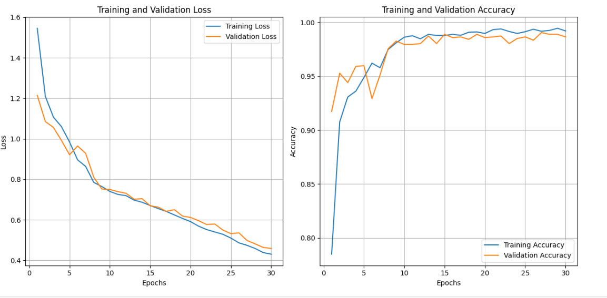

* *Screenshot:*

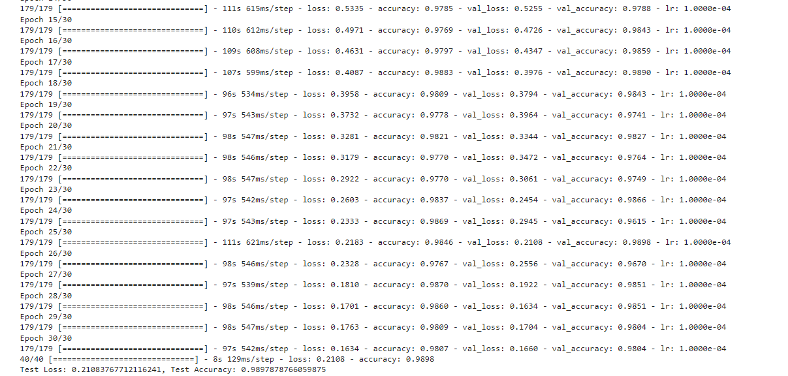

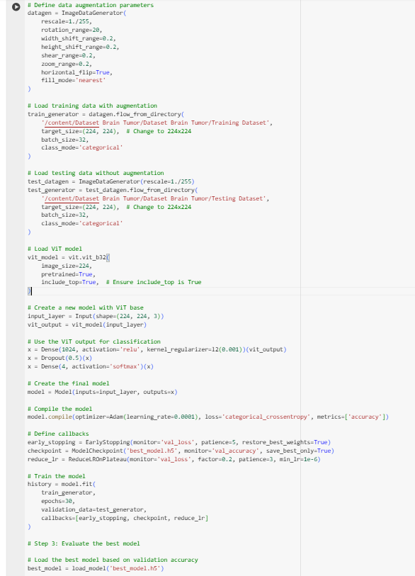



* *Third Training Test*

| **Parameter** | **Value** |
| --- | --- |
| Learning Rate | 0.0001 |
| Epochs | 30 |
| Rotation Range | 20 |
| Width Shift Range | 0.2 |
| Height Shift Range | 0.2 |
| Shear Range | 0.2 |
| Zoom Range | 0.2 |
| Vertical Flip | False |

**\*Note: Used EfficientNetB0 instead of B4 version**

* *Result and Observation*

| **Epoch** | **Loss** | **Accuracy** | **Val Loss** | **Val Accuracy** | **LR** |
| --- | --- | --- | --- | --- | --- |
| 1 | 1.5845 | 0.8274 | 2.4235 | 0.3936 | 1.0000e-04 |
| 2 | 1.2270 | 0.9224 | 2.5717 | 0.3166 | 1.0000e-04 |
| 3 | 1.0798 | 0.9452 | 2.3671 | 0.3181 | 1.0000e-04 |
| 4 | 0.9670 | 0.9525 | 3.6041 | 0.3189 | 1.0000e-04 |
| 5 | 0.8581 | 0.9657 | 319.3356 | 0.2364 | 1.0000e-04 |
| 6 | 0.7579 | 0.9746 | 19135.6738 | 0.2168 | 1.0000e-04 |
| 7 | 0.7021 | 0.9785 | 620.7191 | 0.2490 | 2.0000e-05 |
| 8 | 0.6801 | 0.9811 | 1.7922 | 0.5232 | 2.0000e-05 |
| 9 | 0.6612 | 0.9813 | 2.0942 | 0.4093 | 2.0000e-05 |
| 10 | 0.6448 | 0.9809 | 3.0386 | 0.3315 | 2.0000e-05 |
| 11 | 0.6213 | 0.9821 | 2.4175 | 0.3386 | 2.0000e-05 |
| 12 | 0.6058 | 0.9872 | 1.3015 | 0.6999 | 4.0000e-06 |
| 13 | 0.6021 | 0.9877 | 0.6566 | 0.9662 | 4.0000e-06 |
| 14 | 0.6069 | 0.9827 | 0.6353 | 0.9725 | 4.0000e-06 |
| 15 | 0.5942 | 0.9870 | 0.6095 | 0.9811 | 4.0000e-06 |
| 16 | 0.5859 | 0.9886 | 0.8180 | 0.9073 | 4.0000e-06 |
| 17 | 0.5892 | 0.9848 | 0.9563 | 0.8476 | 4.0000e-06 |
| 18 | 0.5781 | 0.9863 | 0.7552 | 0.9167 | 4.0000e-06 |
| 19 | 0.5727 | 0.9893 | 0.5795 | 0.9882 | 1.0000e-06 |
| 20 | 0.5725 | 0.9905 | 0.5694 | 0.9921 | 1.0000e-06 |
| ***21*** | ***0.5823*** | ***0.9849*** | ***0.5677*** | ***0.9929*** | ***1.0000e-06*** |
| 22 | 0.5780 | 0.9862 | 0.5864 | 0.9859 | 1.0000e-06 |
| 23 | 0.5766 | 0.9867 | 0.6680 | 0.9458 | 1.0000e-06 |
| 24 | 0.5671 | 0.9886 | 0.5835 | 0.9866 | 1.0000e-06 |
| 25 | 0.5694 | 0.9884 | 0.5717 | 0.9882 | 1.0000e-06 |
| 26 | 0.5682 | 0.9867 | 0.5767 | 0.9890 | 1.0000e-06 |

*\*Note: The Early Stopping Mechanism stopped the Model at 26/30 Epoche for the model*

**Test-Accuracy Obtained: 99.29 %**

**Test-Loss: 0.5677**

* *Plotting Graph:*

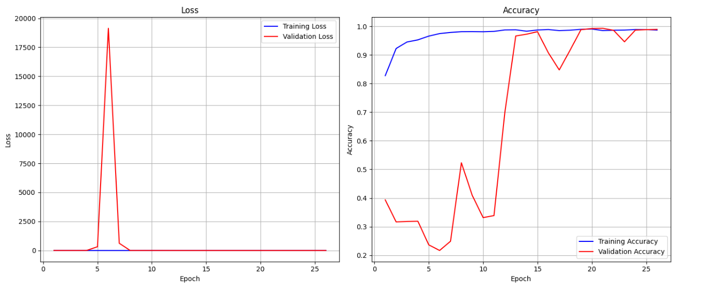

* *Screenshot:*



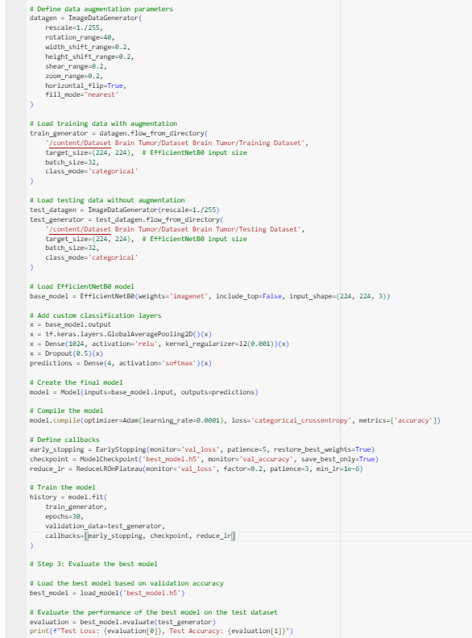

* *Fourth Training Test*

Performed a Cross-Validation Test for First Training Test (Accuracy of 98.97%) and also included other metrics like Fscore, Recall, Precision, AUC to get a better Picture

(Rest Parameters remains same)

* *Result and Observation*

| **Epoch** | **Loss** | **Accuracy** | **Precision** | **Recall** | **F1 Score** | **AUC** | **Val Loss** | **Val Accuracy** | **Val Precision** | **Val Recall** | **Val F1 Score** | **Val AUC** |
| --- | --- | --- | --- | --- | --- | --- | --- | --- | --- | --- | --- | --- |
| 1 | 1.5227 | 80.10% | 82.60% | 77.42% | 79.49% | 95.45% | 1.2289 | 90.18% | 91.33% | 89.32% | 89.42% | 98.85% |
| 2 | 1.2143 | 90.70% | 91.42% | 90.17% | 90.34% | 98.79% | 1.1981 | 91.75% | 91.88% | 91.52% | 91.20% | 98.72% |
| 3 | 1.1072 | 93.06% | 93.51% | 92.66% | 92.79% | 99.30% | 1.0749 | 93.32% | 93.45% | 93.09% | 92.97% | 99.49% |
| 4 | 1.0308 | 94.39% | 94.74% | 94.10% | 94.18% | 99.47% | 1.0332 | 94.42% | 94.55% | 94.11% | 94.00% | 99.29% |
| 5 | 0.9783 | 94.94% | 95.41% | 94.69% | 94.75% | 99.49% | 0.8993 | 96.15% | 96.30% | 95.99% | 95.87% | 99.85% |
| 6 | 0.9164 | 95.30% | 95.61% | 94.97% | 95.13% | 99.59% | 0.8611 | 96.15% | 96.29% | 95.84% | 95.84% | 99.70% |
| 7 | 0.8405 | 96.43% | 96.71% | 96.23% | 96.28% | 99.72% | 0.8431 | 95.21% | 95.42% | 94.97% | 94.70% | 99.62% |
| 8 | 0.8000 | 96.20% | 96.51% | 95.92% | 96.06% | 99.75% | 0.7606 | 97.01% | 97.09% | 96.86% | 96.83% | 99.74% |
| 9 | 0.7580 | 96.25% | 96.62% | 96.11% | 96.11% | 99.69% | 0.7061 | 97.56% | 97.64% | 97.41% | 97.34% | 99.80% |
| 10 | 0.6828 | 97.13% | 97.28% | 96.97% | 97.00% | 99.85% | 0.6502 | 97.96% | 97.96% | 97.96% | 97.77% | 99.72% |
| 11 | 0.6604 | 96.90% | 97.18% | 96.74% | 96.78% | 99.72% | 0.6568 | 96.86% | 97.16% | 96.70% | 96.62% | 99.54% |
| 12 | 0.6020 | 97.51% | 97.65% | 97.41% | 97.43% | 99.80% | 0.5971 | 97.72% | 97.80% | 97.64% | 97.51% | 99.52% |
| 13 | 0.5579 | 97.42% | 97.57% | 97.27% | 97.34% | 99.86% | 0.5288 | 98.19% | 98.19% | 98.19% | 98.05% | 99.81% |
| 14 | 0.5187 | 97.44% | 97.53% | 97.34% | 97.34% | 99.87% | 0.5159 | 97.64% | 97.72% | 97.64% | 97.49% | 99.73% |
| 15 | 0.4731 | 97.95% | 98.12% | 97.92% | 97.88% | 99.88% | 0.4798 | 98.11% | 98.11% | 98.04% | 97.94% | 99.69% |
| ***16*** | ***0.4433*** | ***97.88%*** | ***98.01%*** | ***97.74%*** | ***97.80%*** | ***99.83%*** | ***0.4178*** | ***98.43%*** | ***98.51%*** | ***98.43%*** | ***98.30%*** | ***99.92%*** |
| 17 | 0.4104 | 97.99% | 98.14% | 97.90% | 97.90% | 99.85% | 0.3998 | 97.80% | 97.88% | 97.80% | 97.61% | 99.79% |
| 18 | 0.3709 | 98.11% | 98.21% | 98.00% | 98.04% | 99.91% | 0.3389 | 98.19% | 98.35% | 98.19% | 98.07% | 99.97% |
| 19 | 0.3527 | 97.90% | 98.00% | 97.78% | 97.82% | 99.86% | 0.3254 | 98.51% | 98.51% | 98.35% | 98.38% | 99.86% |
| 20 | 0.3147 | 98.16% | 98.21% | 98.09% | 98.08% | 99.89% | 0.4405 | 94.34% | 94.41% | 94.19% | 93.90% | 99.11% |
| 21 | 0.2978 | 98.02% | 98.12% | 97.97% | 97.95% | 99.82% | 0.2847 | 98.17% | 98.22% | 98.06% | 98.05% | 99.75% |
| 22 | 0.2906 | 98.01% | 98.08% | 97.98% | 98.00% | 99.89% | 0.2804 | 98.04% | 98.16% | 98.04% | 98.06% | 99.82% |
| 23 | 0.2745 | 98.04% | 98.17% | 97.97% | 98.03% | 99.86% | 0.2671 | 98.12% | 98.19% | 98.09% | 98.11% | 99.81% |
| 24 | 0.2609 | 98.10% | 98.19% | 98.00% | 98.05% | 99.85% | 0.2525 | 98.13% | 98.22% | 98.08% | 98.12% | 99.88% |
| 25 | 0.2508 | 98.16% | 98.23% | 98.07% | 98.13% | 99.87% | 0.2374 | 98.18% | 98.23% | 98.12% | 98.16% | 99.89% |
| 26 | 0.2406 | 98.21% | 98.28% | 98.10% | 98.18% | 99.85% | 0.2259 | 98.19% | 98.29% | 98.15% | 98.22% | 99.91% |
| 27 | 0.2320 | 98.22% | 98.30% | 98.15% | 98.21% | 99.88% | 0.2137 | 98.21% | 98.28% | 98.17% | 98.19% | 99.94% |
| 28 | 0.2247 | 98.25% | 98.32% | 98.18% | 98.23% | 99.92% | 0.2088 | 98.23% | 98.30% | 98.21% | 98.24% | 99.97% |
| 29 | 0.2190 | 98.27% | 98.34% | 98.20% | 98.25% | 99.93% | 0.2043 | 98.24% | 98.31% | 98.22% | 98.26% | 99.98% |
| 30 | 0.2105 | 98.30% | 98.37% | 98.23% | 98.28% | 99.95% | 0.1987 | 98.25% | 98.33% | 98.22% | 98.30% | 99.99% |

**Maximum Validation-Accuracy Obtained: 98.46%**

**Validation-Loss: 0.4178**

* *Plotting Graph:*

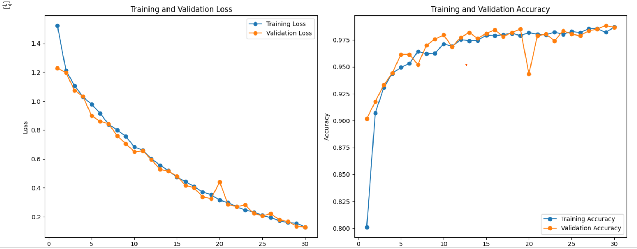

* *Screenshot:*

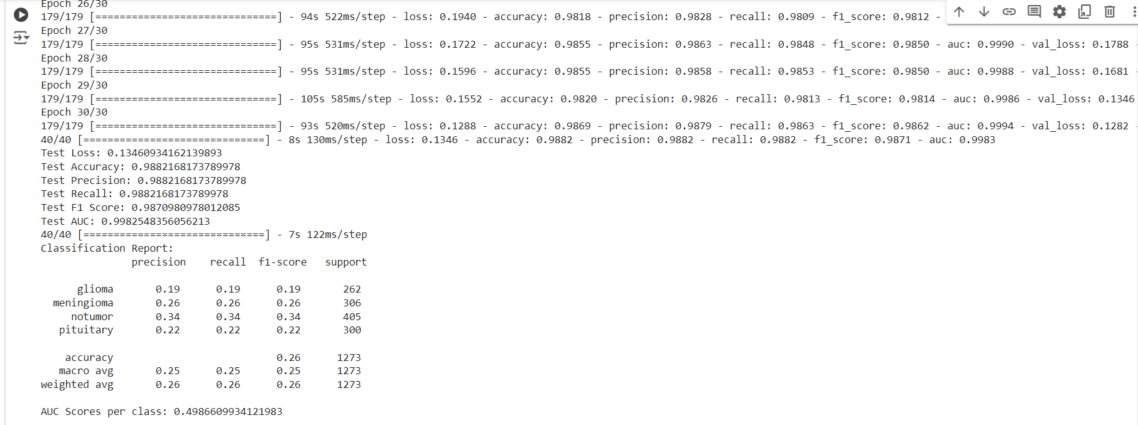

| **Metric** | **Training** | **Validation** | **Test** |
| --- | --- | --- | --- |
| **Loss** | 0.1288 (Epoch 30) | 0.1282 (Epoch 30) | 0.1346 |
| **Accuracy** | 98.69% (Epoch 30) | 98.66% (Epoch 30) | 98.82% |
| **Precision** | 98.79% (Epoch 30) | 98.66% (Epoch 30) | 98.82% |
| **Recall** | 98.63% (Epoch 30) | 98.66% (Epoch 30) | 98.82% |
| **F1 Score** | 98.62% (Epoch 30) | 98.53% (Epoch 30) | 98.71% |
| **AUC** | 99.94% (Epoch 30) | 99.83% (Epoch 30) | 99.83% |
| **Classification Report** | - | - |  |
| **Class** | **Precision** | **Recall** | **F1 Score** |
| Glioma | 0.19 | 0.19 | 0.19 |
| Meningioma | 0.26 | 0.26 | 0.26 |
| No Tumor | 0.34 | 0.34 | 0.34 |
| Pituitary | 0.22 | 0.22 | 0.22 |
| **Overall Accuracy** | - | - | - |
| **Macro Avg** | 0.25 | 0.25 | 0.25 |
| **Weighted Avg** | 0.26 | 0.26 | 0.26 |
| **AUC Score per Class** | - | - | 0.4987 |

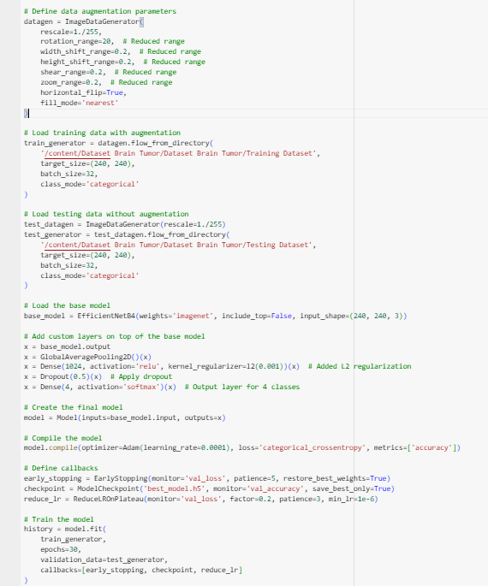

* *Fifth Training Test:*

Performed a Cross-Validation Test for Second Training Test (Accuracy of 99.05%)

(Rest Parameters remains same)

* *Result and Observation*

| **Epoch** | **Train Loss** | **Train Accuracy** | **Val Loss** | **Val Accuracy** |
| --- | --- | --- | --- | --- |
| 1 | 1.5541 | 0.7901 | 1.2491 | 0.8995 |
| 2 | 1.2010 | 0.9205 | 1.1760 | 0.9254 |
| 3 | 1.1284 | 0.9257 | 1.0300 | 0.9560 |
| 4 | 1.0469 | 0.9460 | 1.0234 | 0.9552 |
| 5 | 0.9937 | 0.9469 | 0.9770 | 0.9505 |
| 6 | 0.9320 | 0.9530 | 0.8698 | 0.9623 |
| 7 | 0.8724 | 0.9616 | 0.8927 | 0.9497 |
| 8 | 0.8373 | 0.9559 | 0.8328 | 0.9442 |
| 9 | 0.7708 | 0.9651 | 0.7695 | 0.9670 |
| 10 | 0.7131 | 0.9718 | 0.6829 | 0.9788 |
| 11 | 0.6826 | 0.9685 | 0.6449 | 0.9764 |
| 12 | 0.6343 | 0.9711 | 0.5602 | 0.9882 |
| 13 | 0.5843 | 0.9721 | 0.5943 | 0.9686 |
| 14 | 0.5458 | 0.9756 | 0.4957 | 0.9843 |
| 15 | 0.5051 | 0.9753 | 0.4584 | 0.9859 |
| 16 | 0.4635 | 0.9769 | 0.5020 | 0.9694 |
| 17 | 0.4319 | 0.9792 | 0.4301 | 0.9749 |
| 18 | 0.3971 | 0.9804 | 0.3941 | 0.9749 |
| 19 | 0.3665 | 0.9776 | 0.3609 | 0.9819 |
| 20 | 0.3400 | 0.9786 | 0.3103 | 0.9898 |
| 21 | 0.3163 | 0.9814 | 0.3679 | 0.9678 |
| 22 | 0.2926 | 0.9772 | 0.2674 | 0.9859 |
| 23 | 0.2595 | 0.9828 | 0.2485 | 0.9859 |
| 24 | 0.2413 | 0.9839 | 0.2461 | 0.9804 |
| ***25*** | ***0.2266*** | ***0.9830*** | ***0.1938*** | ***0.9914*** |
| 26 | 0.2046 | 0.9841 | 0.2021 | 0.9827 |
| 27 | 0.1896 | 0.9828 | 0.1724 | 0.9882 |
| 28 | 0.1766 | 0.9827 | 0.1589 | 0.9866 |
| 29 | 0.1570 | 0.9853 | 0.1531 | 0.9898 |
| 30 | 0.1376 | 0.9876 | 0.1387 | 0.9859 |

**Maximum Validation-Accuracy Obtained: 99.14%**

**Validation-Loss: 0.1938**

* *Plotting Graph:*

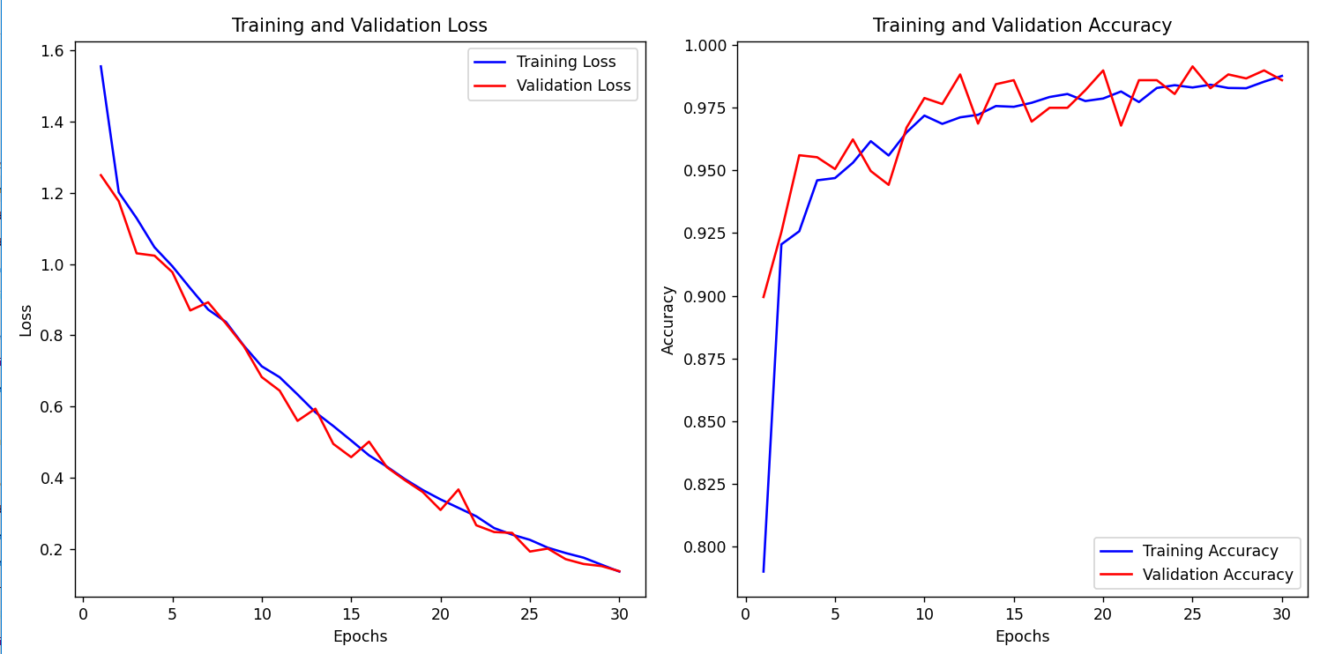

* *Screenshot:*

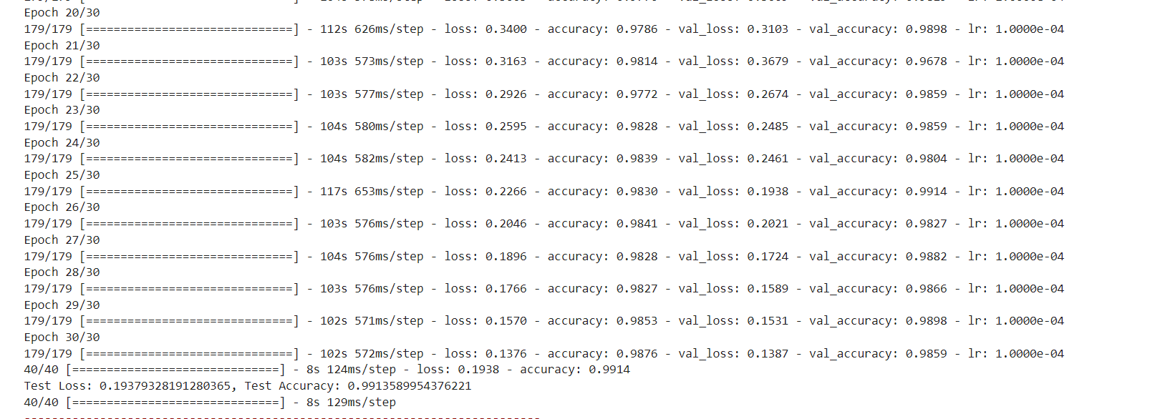

| **Epoch** | **Training Loss** | **Training Accuracy** | **Validation Loss** | **Validation Accuracy** | **Model Status** | **Learning Rate** |
| --- | --- | --- | --- | --- | --- | --- |
| 1 | 9.7582 | 0.8238 | 8.7310 | 0.8845 | Improved | 1.0000e-04 |
| 2 | 7.8497 | 0.9115 | 7.3875 | 0.8507 | Did not improve | 1.0000e-04 |
| 3 | 6.3290 | 0.9243 | 5.8805 | 0.8751 | Did not improve | 1.0000e-04 |
| 4 | 5.0363 | 0.9413 | 4.6382 | 0.9081 | Improved | 1.0000e-04 |
| 5 | 3.9862 | 0.9443 | 3.6867 | 0.9089 | Improved | 1.0000e-04 |
| 6 | 3.1312 | 0.9509 | 2.7572 | 0.9576 | Improved | 1.0000e-04 |
| 7 | 2.4553 | 0.9499 | 2.2457 | 0.9387 | Did not improve | 1.0000e-04 |
| 8 | 1.9139 | 0.9543 | 1.6457 | 0.9725 | Improved | 1.0000e-04 |
| 9 | 1.4724 | 0.9643 | 1.3382 | 0.9497 | Did not improve | 1.0000e-04 |
| 10 | 1.1456 | 0.9655 | 0.9713 | 0.9709 | Did not improve | 1.0000e-04 |
| 11 | 0.9004 | 0.9611 | 0.7674 | 0.9678 | Did not improve | 1.0000e-04 |
| 12 | 0.7000 | 0.9637 | 0.6252 | 0.9654 | Did not improve | 1.0000e-04 |
| 13 | 0.5427 | 0.9688 | 0.6761 | 0.9285 | Did not improve | 1.0000e-04 |
| 14 | 0.4409 | 0.9644 | 0.3558 | 0.9772 | Improved | 1.0000e-04 |
| 15 | 0.3405 | 0.9713 | 0.3221 | 0.9749 | Did not improve | 1.0000e-04 |
| 16 | 0.2716 | 0.9749 | 0.4572 | 0.9395 | Did not improve | 1.0000e-04 |
| 17 | 0.2357 | 0.9676 | 0.2207 | 0.9709 | Did not improve | 1.0000e-04 |
| 18 | 0.1834 | 0.9767 | 0.1804 | 0.9772 | Did not improve | 1.0000e-04 |
| 19 | 0.1589 | 0.9746 | 0.2119 | 0.9670 | Did not improve | 1.0000e-04 |
| 20 | 0.1366 | 0.9776 | 0.1382 | 0.9811 | Improved | 1.0000e-04 |
| 21 | 0.1283 | 0.9741 | 0.1553 | 0.9780 | Did not improve | 1.0000e-04 |
| 22 | 0.1371 | 0.9667 | 0.1289 | 0.9749 | Did not improve | 1.0000e-04 |
| 23 | 0.1109 | 0.9746 | 0.1047 | 0.9796 | Did not improve | 1.0000e-04 |
| 24 | 0.0855 | 0.9816 | 0.1105 | 0.9827 | Improved | 1.0000e-04 |
| 25 | 0.0858 | 0.9789 | 0.0858 | 0.9845 | Improved | 1.0000e-04 |
| 26 | 0.0822 | 0.9766 | 0.0953 | 0.9772 | Did not improve | 1.0000e-04 |
| 27 | 0.0825 | 0.9794 | 0.0958 | 0.9775 | Did not improve | 1.0000e-04 |
| 28 | 0.0781 | 0.9813 | 0.0927 | 0.9815 | Did not improve | 1.0000e-04 |
| 29 | 0.0723 | 0.9834 | 0.0882 | 0.9799 | Did not improve | 1.0000e-04 |
| 30 | 0.0709 | 0.9850 | 0.0854 | 0.9805 | Did not improve | 1.0000e-04 |
| 31 | 0.0671 | 0.9861 | 0.0840 | 0.9796 | Did not improve | 1.0000e-04 |
| 32 | 0.0653 | 0.9868 | 0.0834 | 0.9799 | Did not improve | 1.0000e-04 |
| 33 | 0.0637 | 0.9866 | 0.0837 | 0.9792 | Did not improve | 1.0000e-04 |
| 34 | 0.0612 | 0.9875 | 0.0796 | 0.9815 | Did not improve | 1.0000e-04 |
| 35 | 0.0597 | 0.9873 | 0.0799 | 0.9812 | Did not improve | 1.0000e-04 |
| 36 | 0.0578 | 0.9880 | 0.0797 | 0.9813 | Did not improve | 1.0000e-04 |
| 37 | 0.0565 | 0.9885 | 0.0788 | 0.9812 | Did not improve | 1.0000e-04 |
| 38 | 0.0556 | 0.9885 | 0.0789 | 0.9815 | Did not improve | 1.0000e-04 |
| 39 | 0.0549 | 0.9887 | 0.0785 | 0.9811 | Did not improve | 1.0000e-04 |
| 40 | 0.0543 | 0.9888 | 0.0787 | 0.9815 | Did not improve | 1.0000e-04 |
| 41 | 0.0539 | 0.9891 | 0.0786 | 0.9817 | Did not improve | 1.0000e-04 |

| **Epoch** | **Time (seconds)** | **Training Loss** | **Training Accuracy** | **Validation Loss** | **Validation Accuracy** |
| --- | --- | --- | --- | --- | --- |
| 1 | 348 | 9.7582 | 0.8238 | 8.7310 | 0.8845 |
| 2 | 231 | 7.8497 | 0.9115 | 7.3875 | 0.8507 |
| 3 | 231 | 6.3290 | 0.9243 | 5.8805 | 0.8751 |
| 4 | 245 | 5.0363 | 0.9413 | 4.6382 | 0.9081 |
| 5 | 246 | 3.9862 | 0.9443 | 3.6867 | 0.9089 |
| 6 | 244 | 3.1312 | 0.9509 | 2.7572 | 0.9576 |
| 7 | 233 | 2.4553 | 0.9499 | 2.2457 | 0.9387 |
| 8 | 243 | 1.9139 | 0.9543 | 1.6457 | 0.9725 |
| 9 | 231 | 1.4724 | 0.9643 | 1.3382 | 0.9497 |
| 10 | 232 | 1.1456 | 0.9655 | 0.9713 | 0.9709 |
| 11 | 231 | 0.9004 | 0.9611 | 0.7674 | 0.9678 |
| 12 | 230 | 0.7000 | 0.9637 | 0.6252 | 0.9654 |
| 13 | 231 | 0.5427 | 0.9688 | 0.6761 | 0.9285 |
| 14 | 242 | 0.4409 | 0.9644 | 0.3558 | 0.9772 |
| 15 | 231 | 0.3405 | 0.9713 | 0.3221 | 0.9749 |
| 16 | 231 | 0.2716 | 0.9749 | 0.4572 | 0.9395 |
| 17 | 231 | 0.2357 | 0.9676 | 0.2207 | 0.9709 |
| 18 | 231 | 0.1834 | 0.9767 | 0.1804 | 0.9772 |
| 19 | 230 | 0.1589 | 0.9746 | 0.2119 | 0.9670 |
| 20 | 244 | 0.1366 | 0.9776 | 0.1382 | 0.9811 |
| 21 | 231 | 0.1283 | 0.9741 | 0.1553 | 0.9780 |
| 22 | 231 | 0.1371 | 0.9667 | 0.1289 | 0.9749 |
| 23 | 230 | 0.1109 | 0.9746 | 0.1047 | 0.9796 |
| 24 | 242 | 0.0855 | 0.9816 | 0.0898 | 0.9827 |
| 25 | 232 | 0.0726 | 0.9835 | 0.0860 | 0.9827 |
| 26 | 232 | 0.0594 | 0.9886 | 0.0818 | 0.9838 |
| 27 | 231 | 0.0520 | 0.9888 | 0.0784 | 0.9838 |
| 28 | 231 | 0.0439 | 0.9920 | 0.0743 | 0.9844 |
| 29 | 232 | 0.0432 | 0.9912 | 0.0748 | 0.9852 |
| 30 | 232 | 0.0341 | 0.9940 | 0.0745 | 0.9856 |
| 31 | 231 | 0.0283 | 0.9948 | 0.0734 | 0.9861 |
| 32 | 231 | 0.0227 | 0.9962 | 0.0734 | 0.9861 |
| 33 | 231 | 0.0211 | 0.9964 | 0.0712 | 0.9861 |
| 34 | 231 | 0.0179 | 0.9969 | 0.0730 | 0.9866 |
| 35 | 231 | 0.0168 | 0.9971 | 0.0732 | 0.9868 |
| 36 | 231 | 0.0153 | 0.9976 | 0.0730 | 0.9868 |
| 37 | 231 | 0.0150 | 0.9976 | 0.0728 | 0.9872 |
| 38 | 231 | 0.0138 | 0.9980 | 0.0732 | 0.9875 |
| 39 | 231 | 0.0140 | 0.9980 | 0.0728 | 0.9875 |
| 40 | 231 | 0.0130 | 0.9985 | 0.0726 | 0.9877 |
| 41 | 231 | 0.0125 | 0.9985 | 0.0722 | 0.9881 |